Society of the Union of Ivanov followers societies “Release”

The Kazan association of clubs of followers of Teacher Ivanov "Disposal" exists since January 1989 y. and «Association Disposal» is renewed with 2002 г in the Kazan city public charitable organization

(We Result(bring) real facts,
perception(recognition) people of the
Example and the Doctrine of the
expensive(dear) Teacher, as the certificate
of His(its) vitality and continuation of
Evolution of the Sacred Spirit Headed by
the Teacher. (Other reasons
samosvidetelstvovaniya about itself on
a site about the Teacher it is counted not
acceptable, not modest)

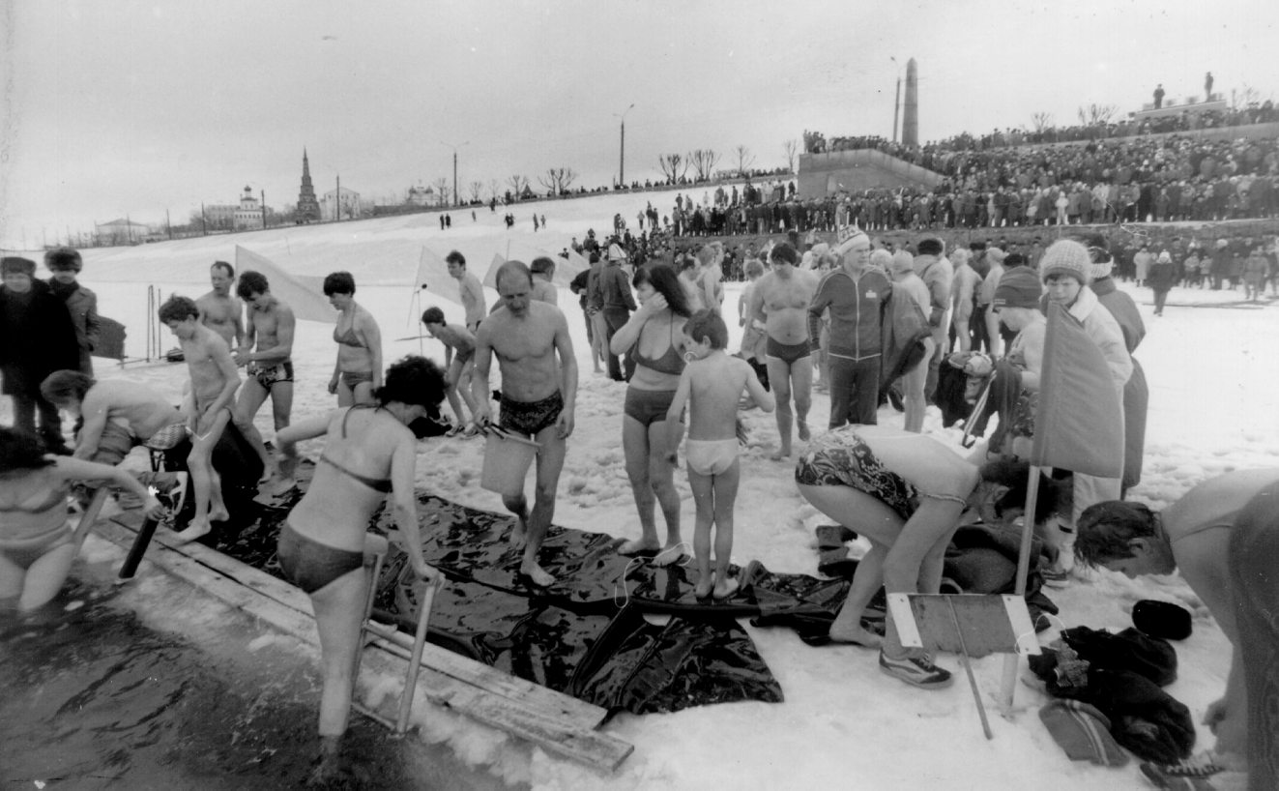

Holiday of a natural way of life at the Kazan Kremlin.

Magazine “Science and Religion” №2,3 1991.
“Take your place in Nature!”
Porfiry Ivanovich Ivanov has a lot of followers today. Nobody has counted till present, but it is safe to suppose that there are many thousands of them. For example, in Kazan there exists an association of clubs “Deliverance”, where thousands of city’s residents study according to his system. Clubs like this exist at least in 50 cities of the country. If you talk to any of His followers- you will learn that all of them feel like they were born again when they started to practice Ivanov’s system. They say that in search of their own place in Nature, what Ivanov asked them to do, they got rid of illnesses, of fear, unconfidence, and experienced special plenitude of life, it’s importance and sense. Everyone calls Him a Teacher, while some think that God came to Earth in his person, the others are sure that he is a messenger of Space and his mission was to return earth dwellers to the lost path of evolution. Some scientists ( there are a lot of physicians, phylosophers, chemists and physicists among the followers of P.K. Ivanov) explain everything by the action of Universal intellectual substance, the laws which were taught of Ivanov. The majority simply fullfills the commandments of Teacher, which are named “Detka” (This is how he treated everybody), and these people think neither about noosphere, nor the Supreme Mind, nor about what and at what level happens while this in the human body, but they don’t doubt that they improve their body, and spirit, and intellect.
A great number of publications about the natural system of Ivanov appeared lately in different editions, but the interest to it does not vanish. Our editing post testifies to it. The readers ask – whether a new religion appeared in the middle of the 20th century? What is the world outlook sense in Ivanov’s Teaching? Are there among his followers true christians and moslems? What is the difference between his system and the majority of healing systems and methods that became famous recently and claim to heal body and spirit of a man? And so forth and so on. O. T. Brushlinskaya and V.P. Pazilova.

The newspaper “ On construction ”. (Body of the Kazan house-building combine) January, 29, 1991 Taking into account growing interest of people to Porfirija Korneevicha Ivanov's doctrine, strong movement of his(its) followers in Kazan, ours многотиражная the newspaper opens a heading “ SCHOOL " CONSCIENCE ".
We plan to print a technique natural hard Ivanov, to come into close contacts to the Kazan association of clubs " disposals ", to shine(cover) practical experience of application of system Porfirija Korneevicha in clubs and schools followers of his(its) doctrine, the letter of readers, questions and answers.
Edition.
THEY ARE HELPED by the NATURE it Is them we see, pour itself ice water on a frost. From them we hear intimate “ Hello! ”, Being surprised with unusual politeness of the stranger. They do not disturb doctors, militia, court. And who can suffer(bear) us and with easy heart to console and help, how not they? With them you will not drink, not smouk you will not gossip. They manage the lesser quantity(amount) of clothes, food, pleasures, are ready to tell up to self-oblivion about Teacher Ivanov, of love to a nature, about victories above fear, a dissatisfaction and illnesses. Than differently to explain what one person A.Chirushkinu managed to create in Kazan six clubs and already thousand people, uniform spirit with Teacher Ivanovym, change in itself немочь to health, chaos on the order, невежество on consciousness, dishonesty on pure(clean) heart and internal rest? And do(make) so that without violence to introduce all this to people. Even in reply to aggression show care of soul weak spirit and win together. To followers of the doctrine of Ivanov in our city all necessary conditions and for propagation of theoretical knowledge, and an exchange of experience are created: All-Union scientific conferences, clubs in the best palaces, realization еvery Sunday holidays on исцеляющем Blue lake... They welcome guests in many collectives of Kazan, republic and the country. It him(it), to simple people, factory newspapers, and the central magazines, TV and radio, and the main thing - hearts of people more than hundred cities of the country have opened. Their free-of-charge charitable cooperative society " disposal " (May, 8 2002 г it is re-registered in Kazan city public charitable the organization " Association Disposal ") does not demand money, but the donation lives on grateful and has everything, not knowing refusal in requests. All this has formed the basis for a recognition magazine " the Science and religion pro Disposal " of a priority in movement of followers of Teacher Ivanov in the USSR. Can be, it - the beginning of social - natural evolution from свершения an apocalypse to a society of independent people about which predicted item. To. Ivanov? One is undoubtedly, that the fact of such life followers of the doctrine of Ivanov show an opportunity conscientious, uniform spirit of people, that the future of mankind in mutual Love with the Nature. Whether it is a natural Way of self-clearing of Russia - the Example for Mankind? However we give the reader himself to make representation on a number(line) of fragments of life of people, aspiring to live, speaking their words, to a nature. And. Vladimir&.

Newspaper «Tatarstan’s Youth»,
3 December 1989 y

The Universe is in every your cell
The will of the universe is impersonated by Pofirij Korneevich Ivanov
Thank to the 50-years experiment in Nature our compatriot and contemporary Porfirij Korneevich Ivanov? fact that XX century get up for History Century trying to understand every man yourself chances became human being in Nature and to take your in Nature.
The Volumes of evidences of his Deed, exposition on the Exhibition of the Peoples Economy Achievement of the USSR, materials of the scientific conferences (Kiev – 1988 and 1990, Kazan – 1989 and 1990, Leningrad – 1980 and 1990, Moscow – 1988, 1990 and 1991 “the Round Table” in the Health Department of the USSR – the is the February 1990)confirm, that Porfirij Korneevich Ivanov came to the live without necessities, had no need in house clothes, food, water could control the weather, materialize the psychic energy, direct natural forces to heal people from all diseases, impersonated universal Love to all beings and the World’s knowledge from the point of view of the Creator.
His teaching and example gives the opportunity to the thousands of people to reconstruct the lost connections with Nature, that to control health, development, fate, to take your place in Nature.
The Teacher Ivanov displayed the Ideal of the Human Being, has threatened our belief in a Human Being, in the attainability of the Ideal and Showed the Way to – the Way of Love and Conscience!
“Address me, a shy me strongly “the Teacher my Dear, give me my Health” helped will help and will be helping”….
To begin to transform the world beginning with yourself, in the unity with the conscience of all world, impersonated by the Teacher Ivanov.
- To join sprit with the Teacher and his followers to be andible by the world, Nature and with their help to with one’s accidental conceptions about God Nature, oneself, fear, diseases, body whims, alcohol and tobacco dependence, pseudoknowleges, pseudoactivity, entertainment, suggestions overobtaining and other narcotics. To need less and less food, warmth, clothes, house.
- By your own labor in Nature and example to find the strength of spirit, faith in yourself and Nature, to live according to the soul, become yourself, to develop a God in oneself, to be impersonated Love, Conscience, natural, cordial, selfadequate, independent, reasonable, joyful, to take place in Nature and associate with the World as the God with the God.
- To deserve the love of Reasonable Mother Nature and to lead Her forces for life service to help everybody, who need’s and Nature to find immortality and Happiness.
- Society of the Teacher Ivanov followers societies “Release”

The newspaper “ Evening Kazan ”,
January, 27, 1989.
FOR the UNIFICATION With the NATURE
Today from the Palace of culture and engineering of builders was begun with scientific - practical conference “ P.K.Ivanova's System and new этико-ecological thinking in present period ”.
To our readers, probably, it is not necessary to tell about P.K.Ivanova's system much - publications in "Вечерке" were devoted to it(her). For ignorant we shall tell: based on a unification of the person with a nature, she(it) promotes improvement of soul and a body.
At conference such questions, as “ the Embodiment of ideas of V.I.Vernadskogo, by A.L.Chizhevskogo about harmonious interaction of the person and a nature in P.K.Ivanova's practice ”, “ Ноосфера and health ”, “ the Hypothesis about essence and birth of teachers of the Earth ”, “ Психофизические aspects of system of natural improvement of P.K.Ivanova ” and others will be considered. Doctor - practice from different cities of our country (among them, by the way, there will be also N.Bykova from Moscow) will tell about an own operational experience on Ivanov's system. At a seminar known scientists - physicians, among which doctor of medical sciences L.Tsepa, Cand.Biol.Sci. A.Fuki (both - Moscow), and also Dr.Sci.Tech. G.Sergeev (Leningrad) will act.
Conference will be prolonged two days.
Our information(inquiry). In Kazan the beginning to work association "Disposal" which includes clubs of natural improvement of P.K.Ivanova. Enter the name in them each interested person can. The phone for an information: 32-33-25 (from 9 o'clock till 18 o'clock).

The REFERENCE(MANIPULATION)
Participants of scientific - practical conference “ P.K.Ivanova's System and new этико-ecological thinking in present period ”.
We count, that Ivanov's system Porfirija Korneevicha is a basis of the new этико-ecological thinking, the new way of existence allowing the person to take the place in the Nature.
Ideas of item. K.Ivanova have global value for destinies of the world.
Participants of conference address:
- To Political bureau TSK of the CPSU with the request to look at P.K.Ivanova's system as on an optimum and most accessible opportunity evolution mankinds to life without material needs(requirements), to unity with the Nature under laws of life, conscience;
- To Presidium AN of the USSR with the offer to develop the complex program of scientific researches of system of P.K.Ivanova.
- To Ministry of Health of the USSR with the request to generalize experience of doctors of Moscow, Leningrad, Kiev, Kazan etc., using P.K.Ivanova's technique for improvement of people;
- To the Ministry of national education of the USSR with the offer on use of ideas of national philosopher P.K.Ivanova in education of rising generation;
- To mass media with an appeal in every possible way to propagandize P.K.Ivanova's system.

The decision is accepted participants of conference unanimously.

Kazan. 28.01.89 year.

At conference there were representatives of Moscow, Brest, Kiev, Odessa, Sverdlovsk, Izhevsk, Tomsk, Novosibirsk, Arzamas, Nizhnekamsk, Almetyevsk,Bugulma, Naberezhnye Chelny, Ioshkar Ola and other cities.

The newspaper “ The Kazan telegraph ”.
¹ 2 1991 year.
How to survive?
To embody Idea of natural human life in the Nature after Teacher Ivanovym - to such answer to this question there came participants of All-Union scientific - practical conference which have lead(carried out) one of these days Board of a society "Knowledge", the State Committee on ecology, scientific and public organizations of Byelorussia. It already 9-я All-Union conference on problems of a survival on which scientists study and prove Porfirija Korneevicha Ivanov's experience and his(its) numerous followers ("деток".
Many scientists on personal experience of following for Teacher Ivanovym have understood, that evolution of the person and mankind is possible(probable) only in the Nature for the Way from universal values - prosperities due to the Nature to Eternal - to the Law of Love, a direct unification with a conceiving Nature, people.
…. The big hopes scientists and statesmen, especially Byelorussia, connected to experience of the Kazan followers of Teacher Ivanov, you see on the Kazan ground where the Teacher suffered in "психушке", His(its) spirit - “ consciousness of all World ” has revived in thousand followers.
…. Two years back clubs were united in association "Disposal" and have created the same charitable cooperative society from three person. They gratuitously will carry out(spend) under the Doctrine of Teacher Ivanov of lecture, consultation, school " conscience ", make and distribute a photo. Information and methodical materials, stands. Charitable cooperative society " disposal " lives on grateful donations, but have everything, not knowing refusal in requests. … its(her) numerous audience testifies To necessity of school " conscience " changing people, including from 15 cities of the country and a repentance of its(her) some students, i.e. a recognition them of the dishonesty, offences, it occurs owing to comprehension of Eternal values on an example of Teacher Ivanov to the help of a spiritual unification by self awaken with the Teacher and His(its) followers, self-penetrations into consciousness, constant introspection, in particular conducting a spiritual diary. The school includes every Sunday dialogue with "детками" and the Nature on Blue lake, immersing in it(her) on "Детке". All this results to that self-comprehension becomes all way of life, frequently on inspiration and developing intuition, thus, the school is natural.
The charitable cooperative society promotes acceleration of natural - social processes, and working on the program “ From spirituality - to health, the place in the Nature ”. For example: in institute of aviation engineering on special program the club is created, evident propaganda is developed(unwrapped), the bus for winter bathing on Blue lake of employees of institute is allocated weekly. The mass movement on "Childe" guys from an auxiliary boarding school ¹ 8 and groups takes place in a number of schools.
he reasonable force pacifying human elements, criminality because our Love has found the response in the Nature.
…. Followers P.K.Ivanova are center of a growing, homing spiritual generality of people (Cathedral) on a residence, works, studies, in family and so forth As a recognition of it we regard offers to us on the part of participants of conference - representatives of different cities and the organizations, including Byelorussia, and with Pleasure are ready to serve light in people. We have stated all experience in the book "Real fact", which have gratuitously transferred (under their request) Gomel Centr scentific information. In it(her) from 320 pages on 150 are placed by a photo and works of the Teacher.
We can help only to those who has woken up and has realized, that the problem of a survival in the Nature cannot be solved force (НТП) without Love to it(her), Its(her) help. What to be rescued it is possible only own work in the Nature, using boundless natural opportunities of natural people - gods in the Nature, on a Way laid by Teacher Ivanovym.
The Minsk conference has testified comprehension of that for suffering(bearing) ship-wreck, rescue not in the ship and at all in skill to float, and in ability to live at ocean. To the World in the Nature through the World in soul!
The chairman of association "Disposal"
A.Chirushkin.

The newspaper “ Soviet Тatariya ”.
February, 5, 1991.

VIVIFYING SOURCE

In the centre Republican Committe the CPSU on preparation and improvement of professional skill of the staff have begun employment(occupations) of school " conscience " organized by association of clubs of natural improvement under the doctrine of P.K.Ivanova "Disposal".
Agree, still absolutely, recently such it would be simply impossible. So authoritative instance and suddenly addresses to services of the amateur organization preaching obvious philosophical heresy, and going to study at it(her). That, times vary and we shall hope to the best. In conditions of ideological and political crisis the party(set) to find forces for realization of program installations, should be updated not only organizational , but also spiritually. And a vivifying source can become for it(her) the popular wisdom storing(keeping) cleanliness of moral ideals, capable to open an output(exit) from dogmatic frameworks in space of free idea, creative energy.
At the first meeting before party workers the chairman of association A.Chirushkin who has told about main principles of the doctrine of P.K.Ivanova, his(its) difference from other improving systems has acted. It(he) has shown also film about the Teacher, has answered numerous questions.
Already during the first meeting participants have tested appreciable emotional rise. At them the desire to sing a hymn “ Glory of life ” which was executed at the end of conversation has appeared. To whom I could talk, asserted(approved), that for a long time did not test such inflow of forces, a joyful winged sentiments. And you see it was only the most general(common) theoretical acquaintance. Ahead practical employment(occupations) on development of skills of a healthy way of life, merge to a nature, lessons of dialogue …
V.Isaev.

The newspaper "Forward" ( The Kazan’s Air prodaktion undertaking)
April, 21, 1989.
" I CAN GET OUT OF the ROTTEN HOLE "
... The childhood was not so cheerful... Has transferred serious operation on a throat. Years in twenty on my way the wine-glass has met, not giving any value, has tried. In twenty four married. For some reason began to use more, relatives has increased, and friends too. Has fulfilled on construction for an apartment, familiar began even more. To whom something with an electricity you will help, to whom the receiver, the TV repair - everywhere a glass. Both went, and has gone. In 35 I already the alcoholic of the second degree... Fear as have bothered пьянка - a hang-over, пьянка - a hang-over and so until recently. March, 9 has come to наркологам to ask, that have directed again to a hospital. So was cannet. Doctor after informal conversation has given human advice(council): " In a hospital you were - have not helped and for certain will not help. Try to visit rates "Disposal". It is very grateful to it(him) for this advice(council)... Has come on rates to A.Chirushkinu, and a miracle - through some employment of me as if have changed. Has felt huge will power in itself. Has understood, that with the help of the head of rates I can overcome myself. Has tested enormous satisfaction. Has felt, that I can get out of a rotten hole. I think and on the future this confidence will not leave me. It became easier to breathe, look people in the face. In a word, has anew regenerated.. Rates "Disposal" have helped me to return on a former level, you see I the qualified worker, with the big experience. Now I can bring much more advantage(benefit). It is necessary, that not only at our factory, and on all country rates "Disposal" worked to finish with this poison, a wine and vodka.
В. MANIA, the serviceman техотдела 56
Who I was up to rates?.. Same as well as all calcher-drink and the chain smoker.... Through five employment(occupations) I have carried away system P.K. Ivanov... Rates to me have helped to become the person. Have learned to see in life all good. To family visiting of rates by me gave too much. It that I became the nondrinker, and that the wife and two daughters began to be engaged in system P.K. Ivanov. I think, as to the enterprise rates have brought the big advantage(benefit). Even more 20 person, graduates of rates became propagandists and preachers of a sober way of life. Clearly, as economic aspect here in a prize... The Society should encourage such rates and propagandize, it is more shine(cover) in mass media
. And. SPIRIDONOV, shop 44

A bunch of new. forgotten by mankind passed before us in the school. Deliverance-is the first step to Nature, life, ourselves, people....
Jury Gagarin
I am thankful for getting acquainted with the method of P.K.Ivanov. This is. effective. and I make a rule of it. I abandon smoking and alcohol.
M. Shagiev
It’s high time to draw society to normal course, to deliver from green snake and tobacco smoke. I thank people who bring these ideas to us.
Biruchevsky.
... to introduce to schools, and technical colleges. I am sure it will help our society.
Suleimanov.
This (The school of people of natural gifts) is a discovery. this is an opinion that the officials should go through this school. in order to understand deeper the problem of soberness in our society.
Firsov.
The hardening and training in nature of P.K. Ivanov gives cheerfulness of spirit, confidence in tomorrow.
K. Murakshin

From the newspaper “ Kazanskoe Vremya” № 21 8-14.06.2000
Russian newspaper for everybody
Column editor Katya Perova
A Man From Boulevard

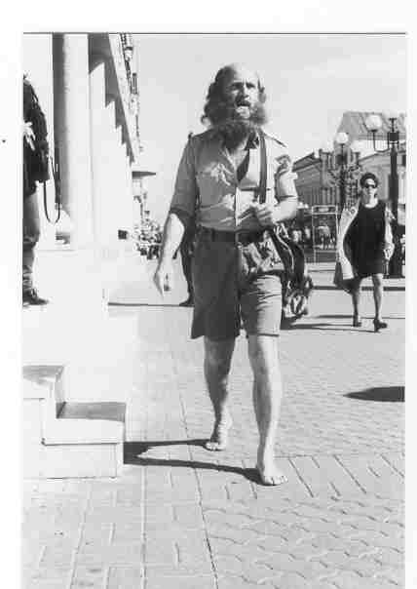 I have lived fourteen years
according to the Ivanov’s system. I
passed all the human way from the
beginning to end. I was a coordinator of
Komsomol in the city of Nabereghnie
Chelny, quit this job and began to
undertake casual labor. But it didn’t
satisfy me. I felt it was not mine. And
there Ivanov’s teaching came to me.
People sell their health and then want to
buy a new one for money. It is not
equivalent. A man can live without
illness at all, because there are great
resources of health in the organism.
I would like to wish the people of
Kazan to pay attention to the example of
Teacher.

Text – Katya Perova, Foto – M . Shakirova.
/

GOVERNMENTAL.
Administration of the president of the Russian Federation
The old area, the house 4, Moscow, Russia, 108132.
Lyadova, 9-76, Kazan, Republic Tatarstan, the Russian Federation 4200336 Чирушкин And.
Many thanks for your letter and the book (« the God of the Nature ») which you have sent addressed to the President of the Russian Federation. We wish you and your relatives of kind health, happiness, well-being!
The adviser of a department of letters A.Karasev.

Magazine " prevention (warning) " ») ¹ 2 ( 20 ), 2002.
(the Appendix to the bulletin « the Healthy way of life »)
Take the place in the Nature
"... The book about Porfirii Ivanov " the God of the Nature " Was published. The book has prepared and big enthusiast Anatoly Chirushkin has let out practically at own risk. It(he) lives in Kazan, heads there association of followers Ivanov "Disposal". Understand, the big money at such associations does not happen. But there is at Chirushkin and his(its) friends a belief that the doctrine and experience Porfiri Korneevich are necessary for people, is especial in our uneasy and not full time. And it is healthy, that twelve-year work Chirushkin has not gone to waste. The book at last was printed in Kazan, for what the author separately thanks publishing house " Татполиграф " which has shown unselfishness in kind business. However, many helped Chirushkin very much, you see followers Ivanov are everywhere.
In the book " the God of the Nature " the material is collected extraordinary interesting and useful to everyone who is interested Ivanov's in doctrine, people of the most various trades and outlooks tell about the meetings, about perception(recognition) Porfiri Korneevich. Their memoirs, their idea, it is sometimes perfect " not brushed ", recreate let at times and inconsistent, but the bright image of the mighty person, whose riddle still will disturb long minds(wits) and hearts of compatriots. And, probably, and not only them... Composers of the collection " the God of the Nature " perfectly do(make), printing, apparently, all known "Chayld" Porfiri Korneevich. As they say, she(it) is known for everything, but not to everyone. And second, to re-read such lines never harmful, you see they are written from hot, big heart... "
Alexander Skljarenko

Newspaper "Telesem" July, 8-14, 2002 ¹ 27
Health
Opens secrets of healthy life
Our joint competition from TV "Ether" - program (« Usual recipes of health ») came to the end. Now we can open to our readers of secret of eternal youth and good health
".... The Winner of competition - Anatoly Chirushkin. It(he) 15 years does not use medicines and did not address to doctors, except for last year's " repairing " teeth because of their small loading. The adherent of system of Ivanov, is poured by cold water and helps people to become healthy. "
(Delivery of a prize and promulgation of results on TV "Ether" was held in birthday Chirushkin)

The newspaper "Life", July, 17-23, 2002 ¹ 28
WISE MAN In COWARDS
Investigation of "Life"
The pupil
"... I, Ivanov Porfiry Korneevich, ask all our Soviet people to participate in this business ". And people has responded to this passionate appeal. Almost in each Soviet court yard were poured by cold water. " To not be spat, refuse food and water from six o'clock in the evening Fridays till midday of Sunday ", - was transferred by word of mouth.
.... In the "Stalin" house in Airbuilding area of Kazan of a wall of one of apartments are entirely covered with portraits of the Teacher. On a question " how old are you? " Former komsomol’s the worker, and nowadays the chairman of association of followers Ivanov Anatoly Chirushkin answers:
- And at me year back run.
In the eightieth in Kazan operated about ten clubs of followers Ivanov. Now, is distressed Chirushkin , times not those, enthusiasts have dissipated.
- Be accurate with the facts... The Pupil " addressed the correspondent of "Life".
N.Pohorukov.

